Name: ……………….………………………………………Signature: ……………………..



DIVINE SECONDARY SCHOOL KITALA
S.1 CHEMISTRY
MID TERM ONE 2024
Time: 1hr 30 mins

INSTRUCTION:
• This paper consists of four questions.

• Answer all questions in the spaces provide

1. Throughout ages, curiosity has made man to explore more about his surrounding and the things that make livelihood meaningful. In doing so, a lot of knowledge about substances has been built up, this partly makes up what we call chemistry.

(a) Give a brief description of the meaning of the term chemistry. (01 marks)

……………………………………………………………………………………………

b) Chemistry is said to be a laboratory science. Give a reason why chemistry is categorized as a laboratory science.
…………………………………………………………………………………………………………………………………………………………………………………………………………………………………………………………………………………………………………………………………………………………………………………….....................................

c) State four ways in which chemistry has contributed to our society
2.Chemistry is one of the most prestigious science subjects studied at the secondary level of Education. When you study chemistry, you not only acquire knowledge about many chemical reactions and other substances, but you can also take up various careers after school.

(a) Identify any three careers that you can take up through studying chemistry. (03 marks)

………………………………………………………………………………………………

………………………………………………………………………………………………

………………………………………………………………………………………………

(b) Briefly describe how the knowledge of chemistry has been applied in the following field in the Ugandan economy;

(i) Agriculture. (03 marks)

………………………………………………………………………………………

………………………………………………………………………………………

………………………………………………………………………………………

………………………………………………………………………………………

(ii) Medicine. (02 marks)

………………………………………………………………………………………

………………………………………………………………………………………

………………………………………………………………………………………

(iii) Cosmetics industry. (02 marks)

………………………………………………………………………………………

………………………………………………………………………………………

………………………………………………………………………………………
3. The list below shows some apparatuses used in a chemistry laboratory, draw and state one use of each in a Chemistry lab. (10 marks)

Apparatus | Diagram | Uses
beaker
Spatula
Filter funnel
Test tubes

SECTION B

As a young Chemistry student, organize a two hour work shop for the people of your community to sensitize them on economic contributions of chemistry to the economy of Uganda so as they can appreciate the use of Chemistry in everyday life.
Use the resource in the figure below.

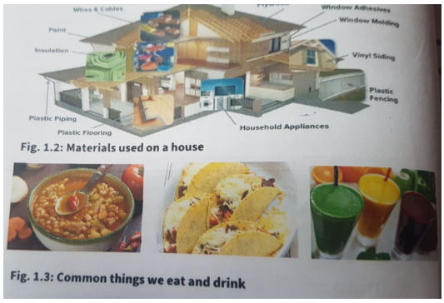

SET BY; TR. SSEMATIMBA GODFREY(BSE NU)

END

